Online Automobile Configurator

Version 1.0.0

Software Requirements Specification

Rossen Kolev  
Stanislava Spasova  
Rumyana Todorova  
Milen Sharkov  
Christina Nikolova

Prepared for  
Software University – QA Fundamentals  
Instructor: Ivan Yonkov

**1.0. Introduction**

***1.1. Purpose***

The purpose of this document is to present a detailed description of the Online Automobile Configurator. It will explain the purpose and features of the configurator, the interfaces, what the configurator will do, the constraints under which it must operate and how the system will react to external stimuli. This document is intended for the developers and stakeholders and will be available for review by the Software University.

***1.2. Scope of Project***

This software system will be an Online Automobile Configurator for a global cars tuner. The configurator will be designed to allow the tuner’s clients to customize their automobiles online and receive an estimate of time and cost for the aftermarket work done by the tuner. This configurator will allow the user to have the comfort of designing the new looks of their automobile from home. Furthermore they will know how much the new aftermarket parts will cost, how much time it will require for the parts to be installed on their automobile, how much will the tuner charge for the work and how will the finished product look like.  
 The user will be able to select the make and model of their automobile. From there the user will have a wide choice of body parts such as: front bumpers, rear bumpers, side skirts, hoods, spoilers, mirrors, front lights, brake lights, grills, spoilers, rims and tyres. Also interior parts such as: seats, steering wheels, gear shifter knobs, rear view mirrors, aftermarket computer systems. The user will also be able to choose what material to be used, such as: leather or suave.

***1.3. Glossary***

|  |  |
| --- | --- |
| **Term** | **Definition** |
| *OAC* | *Online Automobile Configurator* |
| *Tuner* | *The company for which the Online Automobile Configurator is made* |
| *Garage* | *The place where the user can modify his automobile and preview the changes* |
| *Build* | *An automobile being modified in the Garage* |
| *Complete Build* | *A submitted Build that is up for review by the Build Manager* |
| *Client* | *A user creating his aftermarket automobile build* |
| *Build Viewer* | *A section accessible only to the Build Manager, where he can review all Client submitted builds* |
| *Build Manager* | *A person reviewing the Client’s submitted build* |

***1.4. References***

*<<Will be implemented soon>>*

***1.5. Overview of Document***

The next chapter, the Overall Description section, of this document gives an overview of the functionality of the product. It describes the informal requirements and is used to establish a context for the technical requirements specification in the next chapter.

The third chapter, the Requirements Specification section, of this document is written primarily for the developers and describes in technical terms the details of the functionality of the product.

Both sections of the document describe the same software product in its entirety, but are intended for different audiences and thus use different language.

**2.0. Overall Description**

***2.1. System environment***

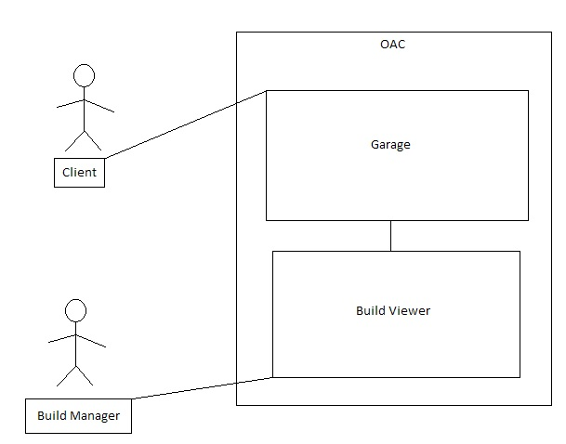

**Figure 1 – Basic System Environment**

The Online Automobile Configurator has two active actors and one cooperating system. The Client access the Garage through the Internet. The Build Manager can see all submitted builds through the Builds View. Any other communication between the Client and the tuner’s representatives will be established via phone or email.

***2.2. Functional Requirements Specification***

This section outlines the use cases for the Client and the Build Manager.

2.2.1. Client Use Case

Use case: **Create Build  
Diagram:**

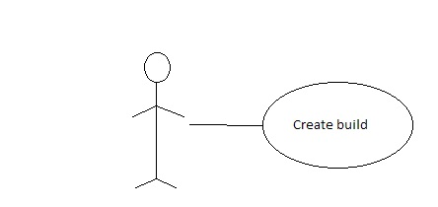

**Brief Description**The Client accesses the Online Automobile Configurator, is redirected to his Garage and begins creating his Build.

**Initial Step-By-Step Description**  
Before this use case can be initiated, the Client has already accessed the Online Automobile Configurator and logged in.

1. The Client selects a Make and Model.
2. The 3D model of the automobile is loaded.
3. The Client selects his desired modifications.
4. The modifications are applied to the Clients automobile.

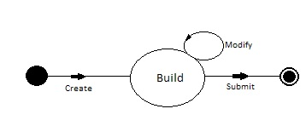

**Figure 2 – Build Submission Process**

The *Build Submission Process* state-transition diagram summarizes how a Client creates his Build and applies the desired Modifications. When he is done, he submits his build for review by the Build Manager. His build is also stored in his Garage.

2.2.2. Build Manager Use Case

Use case: **Review Build  
Diagram:**

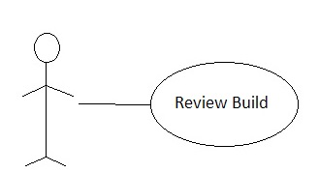

**Brief Description**The Build Manager accesses the Online Automobile Manager and is redirected to the Build Viewer where he can see all submitted builds.

**Initial Step-By-Step Description**Before this use case can be initiated, the Build Manager has already accessed the Online Automobile Configurator and logged in.

1. The Build Manager selects one of the available submitted builds.
2. The 3D model of the submitted build is loaded.
3. The Build Manager reviews all of the Client’s modifications for the selected Build.

2.2.2.1. Build Manager Use Case

Use case: **Approve or Disapprove Build  
Diagram:**

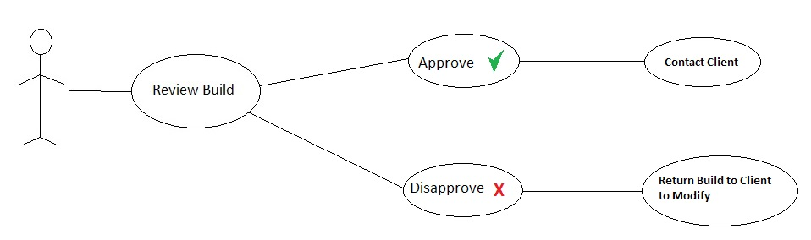

**Brief Description**The Build Manager reviews a Build and then decides if it can be accepted and undergo the Client’s desired modifications in real life.

**Initial Step-By-Step Description**Before this use case can be initiated, the Build Manager has already accessed the Online Automobile Configurator and logged in, at least one Client has submitted a Build for review.

1. The Build Manager selects one of the available submitted builds.
2. The 3D model of the submitted build is loaded.
3. The Build Manager reviews all of the Client’s modifications for the selected Build.
4. The Build Manager decides if the Client’s Build can be accepted and undergo his desired modifications.
   1. If the Build is approved, the Build Manager contacts the Client.
   2. If the Build is disapproved, the Build Manager returns the Build to the Client and provides an explanation why the Build cannot be approved.

***2.3. User Characteristics***

The Client is expected to be Internet literate and be able to navigate through various menus. The main screen of the Client’s Garage will have a menu consisting of different automobile manufacturers, which upon being hovered on will trigger a drop down menu, where all of the available models for that automobile manufacturer are available.  
 The Build Manager is expected to be Internet literate and have knowledge in the processes of tuning an automobile.

***2.4. Non-Functional Requirements***

The Online Automobile Configurator will be deployed on IIS web server and it will use MS SQL server to store data. The physical machine to be used will be determined by the Tuner. The software developed here assumes the use of Entity Framework to make the connection between the website and the database. The speed of the Client’s connection will depend on the hardware used rather than characteristics of this system.

***2.5. <<Coming soon>>***